SECURE NETWORK WITH FIREWALLS NAT

Q1. Set up Windows Defender Firewall on your Windows laptop or PC and create a new inbound rule to block all incoming traffic on port 8080. Take a screenshot of the rule you created.
Ans. Steps to block incoming traffic on port 8080
- Press Windows + R, type wf.msc, and press Enter.
- In Windows Defender Firewall with Advanced Security, click Inbound Rules.
- Click New Rule… on the right side.
- Select Port → Next.
- Select TCP and enter 8080 in Specific local ports → Next.
- Select Block the connection → Next.
- Keep Domain, Private, and Public selected → Next.
- Name the rule Block Incoming Port 8080.
- Click Finish.
- Find Block Incoming Port 8080 in the Inbound Rules list.
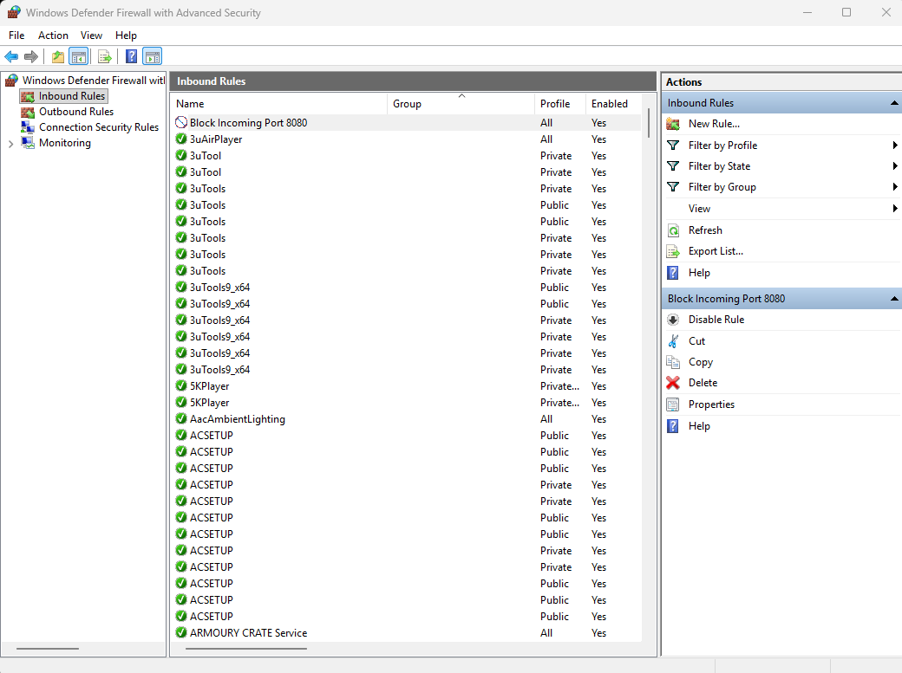

Q2. Simulate NAT (Network Address Translation) by drawing a simple diagram showing how your home Wi-Fi router assigns private IP addresses to your phone, laptop, and smart TV, and how it translates them to a single public IP for internet access. Hint: Use any drawing tool or even hand-draw and click a photo.
Ans.
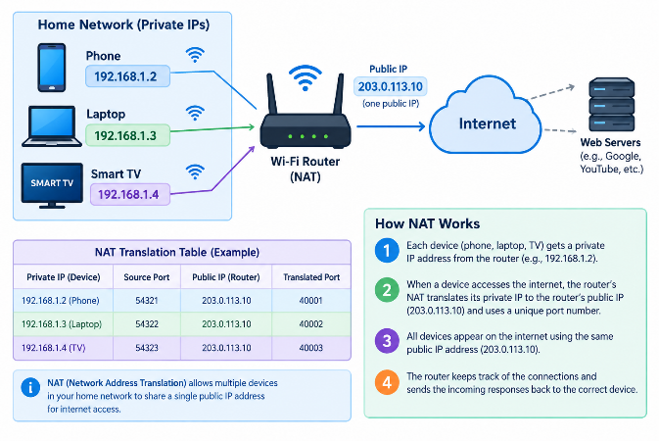
Steps
- Phone, laptop, and smart TV receive private IP addresses from the Wi-Fi router.
- When they access the internet, the router's NAT translates their private IP addresses.
- All devices appear on the internet using one public IP address (203.0.113.10).
- NAT keeps track of which device requested each connection and sends the responses back to the correct device.
Note: The public IP above is an example address for demonstration.
Q3. Configure port filtering using your Wi-Fi router's admin panel (or use a router simulator online if you don't have access). Block outgoing traffic on port 25 (SMTP) and explain in 2 sentences how this could help prevent spam from your network.
Ans. Port Filtering – Block Port 25 (SMTP)
Step 1: Log in to your Wi-Fi router’s admin panel and open Firewall / Access Control / Port Filtering.
Step 2: Create a new rule:
- Direction: Outgoing
- Protocol: TCP
- Destination Port: 25
- Action: Block/Deny
Step 3: Save/apply the rule and test that outgoing connections using port 25 are blocked.
Spam prevention (2 sentences): Blocking outgoing port 25 can stop devices on the network from directly sending email through standard SMTP. This can help limit spam if a device becomes infected with malware that tries to send large numbers of spam emails.
Q4. Given a sample packet filtering rule set (provided by your trainer), identify which of these three sample packets would be allowed or blocked: 1) HTTP request from 192.168.1.5 to 172.217.166.78:80, 2) SSH request from 10.0.0.10 to 34.201.23.1:22, 3) DNS query from 192.168.1.7 to 8.8.8.8:53.< Hint: Focus on source/destination IPs and ports in the rule set.
Ans. To determine the exact result, the trainer’s rule set is required. If we use a typical sample rule set such as the one below:
Packet | Protocol | Result
192.168.1.5 → 172.217.166.78:80 | HTTP / 80 | Allowed
10.0.0.10 → 34.201.23.1:22 | SSH / 22 | Blocked
192.168.1.7 → 8.8.8.8:53 | DNS / 53 | Allowed

Reason: The source/destination IP addresses and destination ports are compared with the filtering rules. HTTP and DNS are allowed, while SSH traffic on port 22 is blocked in this example.
Q5. Reason: The source/destination IP addresses and destination ports are compared with the filtering rules. HTTP and DNS are allowed, while SSH traffic on port 22 is blocked in this example.
Ans. Here are 3 ways Instagram or Zomato could use firewalls and packet filtering to protect their servers. These are general examples; companies do not publicly disclose every firewall rule.
- Block unauthorized ports: Firewalls can allow only required services/ports and block unnecessary ones, reducing opportunities for attackers to reach internal services. Meta describes controlling traffic entering and leaving network segments as part of secure infrastructure.
- Restrict trusted IP addresses: Packet-filtering rules can allow sensitive systems to communicate only with approved IP addresses or network segments. Zomato has publicly stated that its systems used network restrictions and that some systems were accessible only from specific IP addresses.
- Separate important systems: Firewalls can restrict traffic between different network sections—for example, keeping databases and payment systems separate from public-facing servers. Zomato has described using multiple environments and network restrictions to limit the impact of a breach, while Meta describes firewalls as part of its data-center infrastructure.

